Name: Prateek Sachan
Enrollment No.: 18114056
Branch: Computer Science and Engineering
Subbatch: O2

Problem Statement 1:
In this Problem, you have to implement a simple transposition cipher, where this cipher encrypts and decrypts a sequence of characters by dividing the sequence into blocks of size n, where n is specified by the encryption key. If the input text has a length that is not a multiple of n, the last block is padded with null characters ('\0'). In addition to n, the key also specifies two parameters a andb. For each block, the i-th output character, starting from 0 as usual, is set to the j-th input character, where j = (ai + b) mod n. For appropriate choices of a and b, this will reorder the characters in the block in a way that can be reversed by choosing a corresponding decryption key (n, a′, b′).
Data Structures Used:
- Linear Array

Algorithm Used:
- Divide input into strings of n characters used the given encryption function.
- Found the decryption keys using inverse modulus.
- Compared the file line by line.

Screenshot:

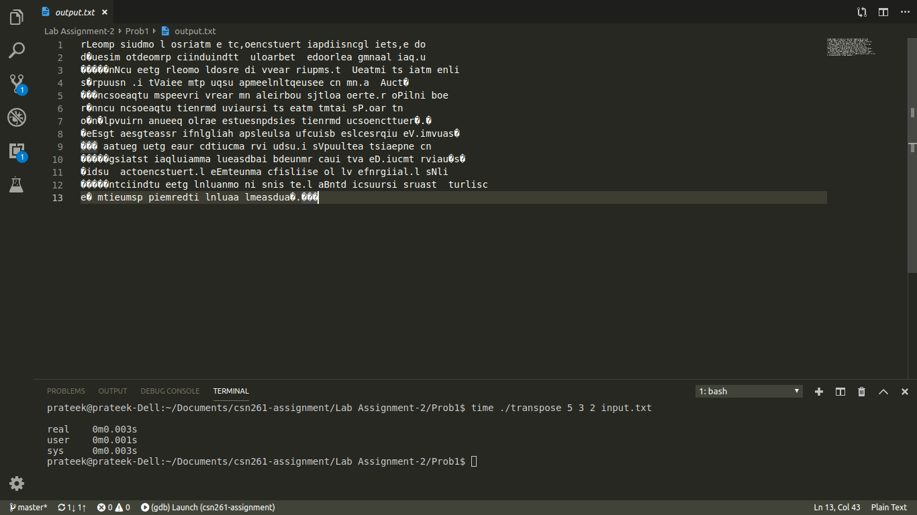
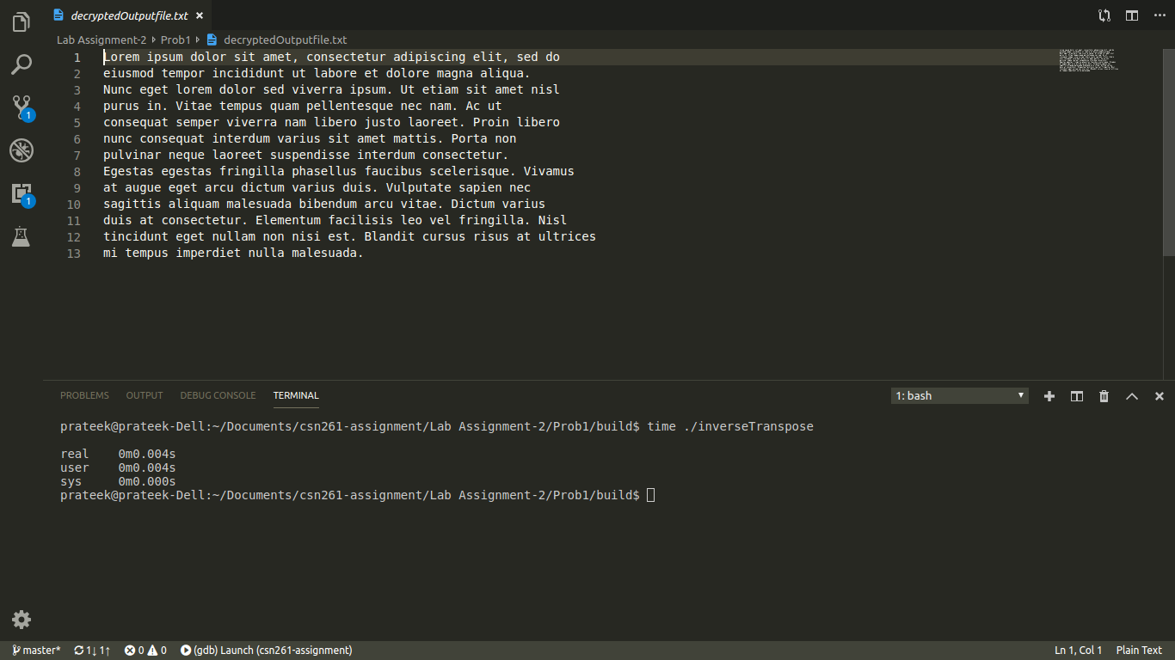

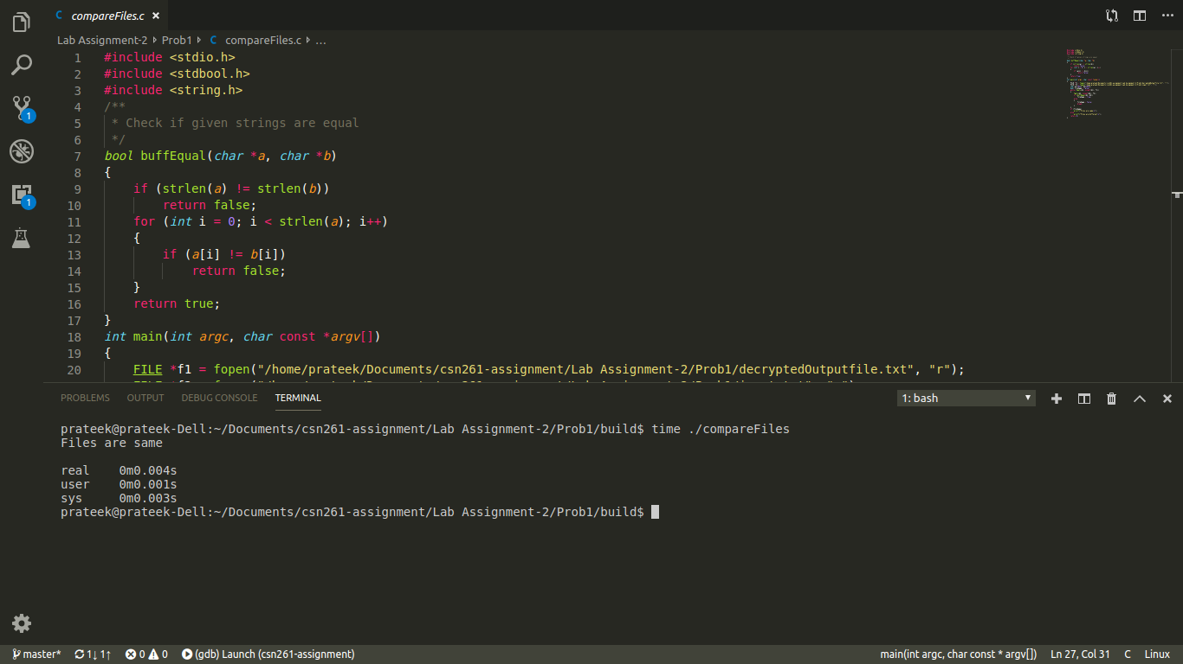
CPU Time:
0.004 s

Problem Statement 2:
A region can be represented either by its interior or by its boundary. Here we represent the region by its interior using one of the most common methods called image array. In this case we have a collection of pixels. Since the number of elements in the array can be quite large, the main objective is to reduce its size by aggregating equal-valued pixels.
Write a C program, MAT.c to represent any region (in image array representation), into its quadtree form.
Data Structure Used:
- Multidimensional Array
- Quad-tree

Algorithm Used:
- Used recursion to generate maximal square.
- Linear traversal
Screenshot:
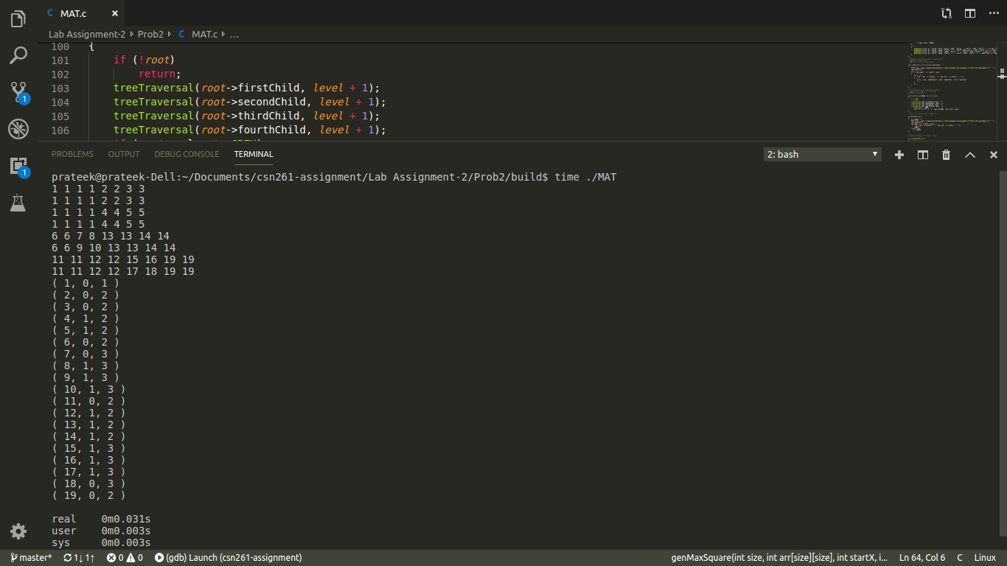
CPU Time:
0.031s

